**UMUC Polygon Test Plan**

Files: Polygon.java, TestPolygon.java

Author: John Bernat

Date: 20Nov2016

**Description:**

This program creates Polygon class and assigns various attributes to objects. The test cases assign various values as parameters when creating objects and adjusts some of the values and retrieves them for output.

**Test Case 1:**

|  |  |  |  |  |
| --- | --- | --- | --- | --- |
| Parameter | Input | Expected Output | Actual Output | Pass/Fail |
| numSides | None (default) | 4 | 4 | Pass |
| sideLength | None (default) | 10.0 | 10.0 | Pass |
| xCoord | None (default) | 0.0 | 0.0 | Pass |
| yCoord | None (default) | 0.0 | 0.0 | Pass |
| Apothem | None (default) | 5.0 | 5.0 | Pass |
| Perimeter | None (default) | 20.0 | 20.0 | Pass |
| Area | None (default) | 50.0 | 50.0 | Pass |
| toString | None (default) | (numSides=4, sideLength=10.0, xCoord=0.0, yCoord=0.0, apothem=5.0, perimeter=20.0) | (numSides=4, sideLength=10.0, xCoord=0.0, yCoord=0.0, apothem=5.0, perimeter=20.0) | Pass |
| setNumSides | 4 | 4 | 4 | Pass |
| setSideLength | 3 | 3.0 | 3.0 | Pass |
| setXCoord | 2.0 | 2.0 | 2.0 | Pass |
| setYCoord | 2.0 | 2.0 | 2.0 | Pass |
| setApothem | 2.0 | 2.0 | 2.0 | Pass |
| setPerimeter | 2.0 | 2.0 | 2.0 | Pass |

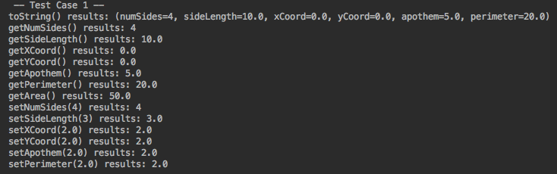

**Test Case 2:**

|  |  |  |  |  |
| --- | --- | --- | --- | --- |
| Parameter | Input | Expected Output | Actual Output | Pass/Fail |
| numSides | 1 | 1 | 1 | Pass |
| sideLength | 2.0 | 2.0 | 2.0 | Pass |
| xCoord | 3.0 | 3.0 | 3.0 | Pass |
| yCoord | 4.0 | 4.0 | 4.0 | Pass |
| Apothem | 5.0 | 5.0 | 5.0 | Pass |
| Perimeter | 6.0 | 6.0 | 6.0 | Pass |
| Area | None | 15.0 | 15.0 | Pass |
| toString | None | (numSides=1, sideLength=2.0, xCoord=3.0, yCoord=4.0, apothem=5.0, perimeter=6.0) | (numSides=1, sideLength=2.0, xCoord=3.0, yCoord=4.0, apothem=5.0, perimeter=6.0) | Pass |
| setNumSides | 6 | 6 | 6 | Pass |
| setSideLength | 5 | 5.0 | 5.0 | Pass |
| setXCoord | 4.0 | 4.0 | 4.0 | Pass |
| setYCoord | 3.0 | 3.0 | 3.0 | Pass |
| setApothem | 2.0 | 2.0 | 2.0 | Pass |
| setPerimeter | 1.0 | 1.0 | 1.0 | Pass |

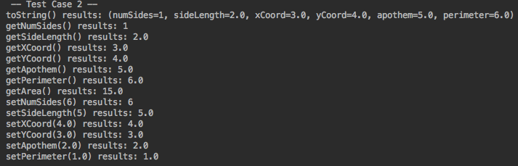

**Test Case 3:**

|  |  |  |  |  |
| --- | --- | --- | --- | --- |
| Parameter | Input | Expected Output | Actual Output | Pass/Fail |
| numSides | 11 | 11 | 11 | Pass |
| sideLength | 12.0 | 12.0 | 12.0 | Pass |
| xCoord | 13.0 | 13.0 | 13.0 | Pass |
| yCoord | 14.0 | 14.0 | 14.0 | Pass |
| Apothem | 15.0 | 15.0 | 15.0 | Pass |
| Perimeter | 16.0 | 16.0 | 16.0 | Pass |
| Area | None | 120.0 | 120.0 | Pass |
| toString | None | (numSides=11, sideLength=12.0, xCoord=13.0, yCoord=14.0, apothem=15.0, perimeter=16.0) | (numSides=11, sideLength=12.0, xCoord=13.0, yCoord=14.0, apothem=15.0, perimeter=16.0) | Pass |
| setNumSides | 16 | 16 | 16 | Pass |
| setSideLength | 15 | 15.0 | 15.0 | Pass |
| setXCoord | 14.0 | 14.0 | 14.0 | Pass |
| setYCoord | 13.0 | 13.0 | 13.0 | Pass |
| setApothem | 12.0 | 12.0 | 12.0 | Pass |
| setPerimeter | 11.0 | 11.0 | 11.0 | Pass |

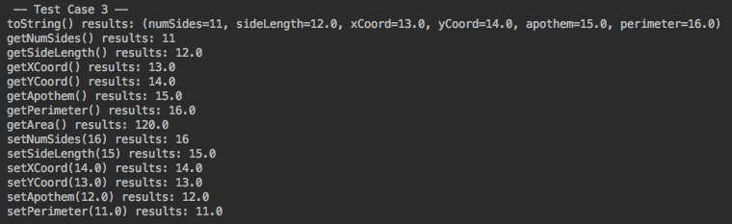

**Test Case 4:**

|  |  |  |  |  |
| --- | --- | --- | --- | --- |
| Parameter | Input | Expected Output | Actual Output | Pass/Fail |
| numSides | 15 | 15 | 15 | Pass |
| sideLength | 25.0 | 25.0 | 25.0 | Pass |
| xCoord | 35.0 | 35.0 | 35.0 | Pass |
| yCoord | 45.0 | 45.0 | 45.0 | Pass |
| Apothem | 55.0 | 55.0 | 55.0 | Pass |
| Perimeter | 65.0 | 65.0 | 66.0 | Pass |
| Area | None | 1787.5 | 1787.5 | Pass |
| toString | None | (numSides=15, sideLength=25.0, xCoord=35.0, yCoord=45.0, apothem=55.0, perimeter=65.0) | (numSides=15, sideLength=25.0, xCoord=35.0, yCoord=45.0, apothem=55.0, perimeter=65.0) | Pass |
| setNumSides | 11 | 11 | 11 | Pass |
| setSideLength | 21 | 21.0 | 21.0 | Pass |
| setXCoord | 31.0 | 31.0 | 31.0 | Pass |
| setYCoord | 41.0 | 41.0 | 41.0 | Pass |
| setApothem | 51.0 | 51.0 | 51.0 | Pass |
| setPerimeter | 61.0 | 61.0 | 61.0 | Pass |

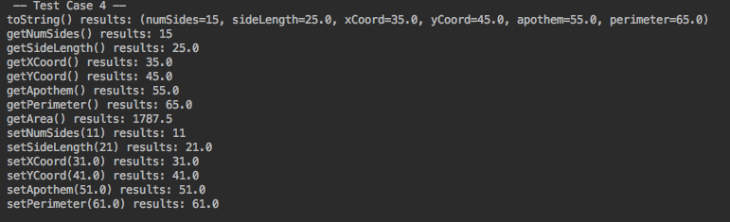

**Test Case 5:**

|  |  |  |  |  |
| --- | --- | --- | --- | --- |
| Parameter | Input | Expected Output | Actual Output | Pass/Fail |
| numSides | 36 | 36 | 36 | Pass |
| sideLength | 112.2 | 112.2 | 112.2 | Pass |
| xCoord | 59.4 | 59.4 | 59.4 | Pass |
| yCoord | 93.2 | 93.2 | 93.2 | Pass |
| Apothem | 2.56 | 2.56 | 2.56 | Pass |
| Perimeter | 234.0 | 234.0 | 234.0 | Pass |
| Area | None | 299.52 | 299.52 | Pass |
| toString |  | (numSides=36, sideLength=112.2, xCoord=59.4, yCoord=93.2, apothem=2.56, perimeter=234.0) | (numSides=36, sideLength=112.2, xCoord=59.4, yCoord=93.2, apothem=2.56, perimeter=234.0) | Pass |
| setNumSides | 54 | 54 | 54 | Pass |
| setSideLength | 87 | 87.0 | 87.0 | Pass |
| setXCoord | 42.4 | 42.4 | 42.4 | Pass |
| setYCoord | 7.47 | 7.47 | 7.47 | Pass |
| setApothem | 245.5 | 245.5 | 245.5 | Pass |
| setPerimeter | 57.45 | 57.45 | 57.45 | Pass |

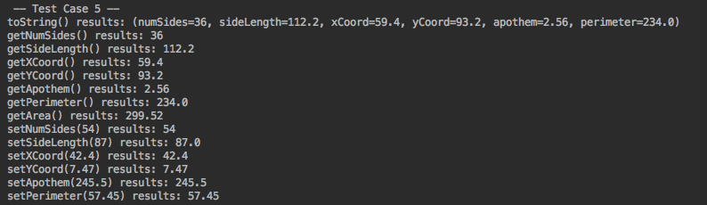

**Test Case 6:**

|  |  |  |  |  |
| --- | --- | --- | --- | --- |
| Parameter | Input | Expected Output | Actual Output | Pass/Fail |
| numSides | 36.5 | 36 | error | Fail |
| sideLength | 2.5 | 2.5 | error | Fail |
| xCoord | 2.5 | 2.5 | error | Fail |
| yCoord | 2.5 | 2.5 | error | Fail |
| Apothem | 2.5 | 2.5 | error | Fail |
| Perimeter | 2.5 | 2.5 | error | Fail |
| Area | None | None | error | Fail |
| toString |  | (numSides=36, sideLength=2.5, xCoord=2.5, yCoord=2.5, apothem=2.5, perimeter=2.5) | error | Fail |
| setNumSides | 3.0 | 3 | error | Fail |
| setSideLength | 3.0 | 3.0 | error | Fail |
| setXCoord | 3.0 | 3.0 | error | Fail |
| setYCoord | 3.0 | 3.0 | error | Fail |
| setApothem | 3.0 | 3.0 | error | Fail |
| setPerimeter | 3.0 | 3.0 | error | Fail |

